Rational Addiction with Excel
Humberto Barreto
Q.G. Noblitt Professor of Economics and Management
DePauw University
Greencastle, IN 46135

May 29-31, 2019 CTREE Conference, St. Louis, MO
Please do not quote without permission.
All comments welcome.

Thanks to Frank M. Howland for corrections and suggestions.

Abstract
Becker and Murphy’s (1988) model of rational addiction that explains why utility-maximizing consumers would buy addictive goods has many applications. It can be incorporated into the content of several different courses in the Economics curriculum—from core Micro courses to elective courses such as Health Economics (e.g., studying cigarette consumption). Unfortunately, the model is difficult to explain and understand. It involves intertemporal choice and a steady state path instead of a single equilibrium point. This paper implements the model of rational addiction in Excel and describes how to use it in the classroom. It eschews all formalism and is targeted for undergraduate Economics majors. Simulation is used to solve the model and comparative statics results are presented with clear visuals. The freely available, macro-enabled Excel workbook can be easily modified for specific examples or extended for use in more advanced classes. It is freely available at http://academic.depauw.edu/~hbarreto/working.
JEL Codes: A2, C6, I1
Keywords: simulation, pedagogy, teaching, optimization, Solver
1. Introduction
Mastery alone does not make an effective teacher. In addition to knowing what they are talking about, teachers must solve a challenging communication problem: content must be presented in a language and format accessible to the student. Traditionally, textbooks play the role of translator, recasting knowledge in a more digestible form.

Some ideas, however, prove especially immune to reduction. If sophisticated mathematics or econometrics were used in the original exposition, then the usual strategies of language simplification, examples, and visual aids would not be enough to enable students to understand the material.

Rational addiction is certainly an example of a situation where the concept requires advanced knowledge. The formal model is way beyond all but a very few undergraduates. The usual solution involves setting up an optimal control problem and then applying the calculus of variations. The vast majority of students have never heard of state variables or Hamiltonians. It is impossible to teach these tools and then apply them. Even the graph depicting the optimal solution requires advanced training. Figure 1, from Folland, et al. (2013, p. 517), offers a textbook presentation.

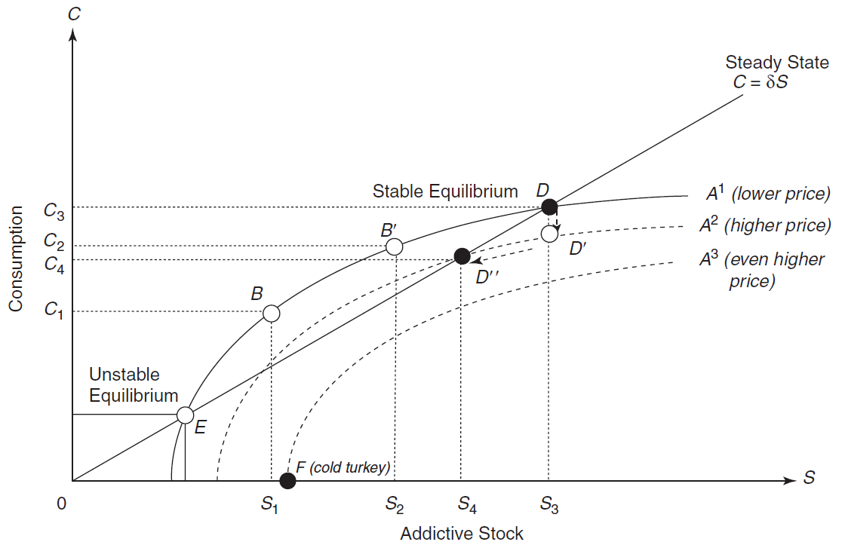
Figure 1: Rational Addiction Model from Folland, et al. (2013).
The typical undergraduate Econ major cannot be expected to grasp what is happening in Figure 1. They would not understand that the initial solution at D is a path, not a point. A professor talking to a class while shifting A curves as price changed would be talking to herself. Teaching this model by ignoring the math and drawing Figure 1 is an exercise in futility, with rote memorization and zero comprehension the inevitable outcome.

But rational addiction is a clever idea that merits inclusion in the Economics curriculum in upper-level electives. Becker and Murphy (1988) is the seminal paper that extended utility maximization to addictive behavior and opened an entirely new research area. They offered a different way to see and study habit formation via the economic way of thinking. In some subfields, such as Health Economics, rational addiction is core material, but it can also serve as additional material in Intermediate Microeconomics for especially bright students.

Since the rational addiction model requires advanced mathematics, the challenge is to translate it so that it can be taught successfully. This paper replaces all the math with Excel’s Solver, a numerical optimization algorithm. It substitutes concrete examples for abstract functional forms, enabling the typical student to work with the model and understand it. In addition to the total absence of formalism, the exposition is designed to be integrated into any curriculum, using any book or the professor’s own notes. Finally, it can be modified or extended as the professor sees fit.

The delivery vehicle is a macro-enabled, standalone Excel workbook, RationalAddiction.xlsm, which can be freely downloaded from http://academic.depauw.edu/~hbarreto/working. This paper serves as a guide to the workbook, explaining how to use it and how to teach rational addiction. Download and open the file now, following along in the Excel workbook as this paper describes how to use it.

The next section offers suggestions for introducing rational addiction. It is followed by a description of how Excel’s Solver is used to find the optimal path for a progression of models based on a simple, quadratic utility function. The comparative statics properties of the model are then highlighted and the conclusion points to courses where this can be used.
2. Setting Up the Problem
Although it is tempting to dive right in, establishing a few fundamental ideas and discussing the nature of the problem is a better pedagogical strategy. The RationalAddiction.xlsm workbook attempts to do this in the Conversation sheet, which is accessed by clicking the Start button at the bottom of the Intro sheet. This sheet can be a reading assignment for the student or the professor can use it to mine a few ideas for an in-class presentation. Simply delete the sheet if you do not want students to see it. With the sheet deleted, the Start button will open the next sheet.

A primary point of the Conversation sheet is to explain that rational addiction is applicable to a broad range of choice problems. Instead of the obvious addictions, such as opioids or alcohol, we are interested in habit formation. In class, the professor could elicit examples of things that are habit forming. Several examples are given in the Conversation sheet (e.g., exercise, video games, food, sports, and love) and there are many, many more. Anything that is more enjoyable the next time it is consumed is a candidate—that is an immensely large set. Asking students to provide their own examples is a good way to show that this is not simply about cigarette, alcohol, or drug addiction.

Becker and Murphy (1988) chose a quotation from Shakespeare to motivate another key aspect of the idea, "How use doth breed a habit in a man!" The Conversation sheet explains the quotation and how addiction is the culmination of a repeated process. Addicts are not instantly produced, instead, use grows over time and the stock of accumulated consumption is a critical factor in addiction.

Another important issue is the fact that some people can break a habit and others cannot. The ability to quit is a serious issue for firms who would much rather have addicted, captive consumers. The Conversation sheet uses the National Football League as an example of this issue. Fans have a considerable stock of invested capital in the game, yet a shock in the form of the deleterious health effects of concussions presents an existential threat. Will football addicts renounce the sport or will their accumulated stock of previous consumption keep them loyal?

Perhaps the most important point to convey when introducing these ideas is that economists model addiction as an optimization problem. The Conversation sheet attempts to explain this as a meta-moment where individuals can and do choose an entire path. Instead of choosing one step at a time, we can see the whole landscape and choose the entire routine itself, optimally, of course. This is a critical aspect of the theory of rational addiction.

Many economics professors would consider talking about these concepts in an informal way a waste of time, however, laying out the issues is an excellent strategy to motivate interest and establish gravitas. It is too easy for a student to dismiss rational addiction as silly—after all, who “chooses” to be a meth addict? Pointing out the wide applicability of situations where present consumption affects the utility of future consumption helps students buy in to the concept.

The Conversation sheet engages the student, presenting key ideas and questions. It is helpful if you are using this workbook as an independent study or standalone assignment. You can safely delete it (or modify it as you wish) if you are presenting the workbook in class.

3. Using Excel’s Solver
Beginning with the 1x sheet, RationalAddiction.xlsm walks the student through a progression of ever more complicated utility maximization problems. These sheets include text that explain what is going on so the workbook can be assigned as a standalone task or used in class (as a lecture or computer lab). In every sheet, Solver is used and analytical solutions using calculus and algebra are ignored. The focus is on the model and optimal solution.

The 1x sheet introduces Solver with a simple optimization problem: $\max_{x}{U}{=18x-3x^{2}}$. The user is asked to call Solver (from the Data tab) and enter the appropriate information in the Solver dialog box. A graph of utility as a function of x is provided. Clicking the Next button near row 33 opens the 2x sheet and the other sheets are opened the same way as the user gets to the bottom of the sheet. As the sheets are opened, a message box is displayed with information about what is coming next and how many sheets remain.

The name 2x indicates that we consider a two time-period, quadratic utility function, $\max_{x}{U}{=18x_{0}-3x_{0}^{2}}+18x_{1}-3x_{1}^{2}$. A discount rate parameter for future utility is introduced and explained. Solver is used to find the optimal values of x at time zero and one. Both 3D and level curve graphs are displayed.

The next sheet, 2xBC, incorporates a budget constraint, which is briefly explained. Solver handles this problem easily and the usual 2D graph with a constraint as a diagonal line is displayed. One possible confusion, Excel’s use of scientific notation, is explained.

Sheet 2xy is the next step in the progression. It introduces another good, y. The user gets ever more comfortable using Solver each time.

The next sheet, 5xy, is critical because it adds the stock of x (S) to the utility function. By having only five time periods, it is easy to see the table and explain each variable. The text in the Excel file urges the student to read carefully, following the step-by-step process. In class, walking through each cell should be strongly emphasized and the trace arrows (explained in the sheet) should be displayed.

The optimal path chart in the sheet should be highlighted and discussed after Solver finds the optimal path. Clearly, the consumer is building a stock of x as part of the optimal solution to the constrained utility maximization problem. This is a key point.

For professors, the analytical solution is included starting in cell AA1. This is not mentioned or discussed at all in the Excel workbook. The analytical solution updates instantly if any changes are made to the exogenous variables. This makes it easy to explore different parameter sets for this problem (you do not have to run Solver each time). It can also be used to confirm that Solver is finding a truly optimal solution. The analytical solution makes it easy to generate (and grade) different problems for homework or other assignments. In a computer lab setting, different students or groups could be given different parameter sets to figure out, for example, how the depreciation rate affects the optimal paths of x, y, and S. Note that a parameter set might produce a path with negative values. Non-negativity constraints can be imposed by Solver if needed.

The last sheet in the progression is 50xyS—the rational addiction model with 50 time periods. This sheet enables the student to see the consumer as choosing an optimal path for x, y, and S. The sheet also points out and explains the concept of the steady state. The optimal time path visual alone is worth the price of admission because conveying the idea that the consumer is choosing a time path (not a point) is absolutely fundamental in the rational addiction model. But the sheet can be used for much more. The next section shows two comparative statics analyses that will help students understand important implications of rational addiction.

Warning: depending on your machine, Solver might take longer than a few seconds. It also might require running again to smooth out a bumpy path. Solver is not perfect and depending on the parameter set and initial values of x and y, may behave badly even with the relatively simple quadratic utility function. Experiments with other functional forms for utility, such as Cobb-Douglas, proved too much for Solver.

4. Comparative Statics
The 50xyS sheet makes it easy to do comparative statics analysis. Change an exogenous variable, then re-optimize (using Solver, of course) to determine the effect of the shock. The live chart was copied and pasted as a picture (so it does not update as the sheet is changed) for easy comparison to the initial parameter set. This provides students with a visual display with which to understand comparative statics. The same approach can be used if you find a different initial parameter set that you prefer. The sheet itself can be copied if needed.

But the rational addiction model is especially focused on a key issue: Why do some people quit after a shock, while others become addicted again? The sheet can be used to offer insight into this crucial question. The instructions under the live chart explain how to create both displays in Figure 2. In (a), a collapse in the stock of x is met by the consumer rebuilding S, becoming re-addicted. In (b), however, the shock also affects the utility function and the consumer does not return to the high levels of S—this is quitting.

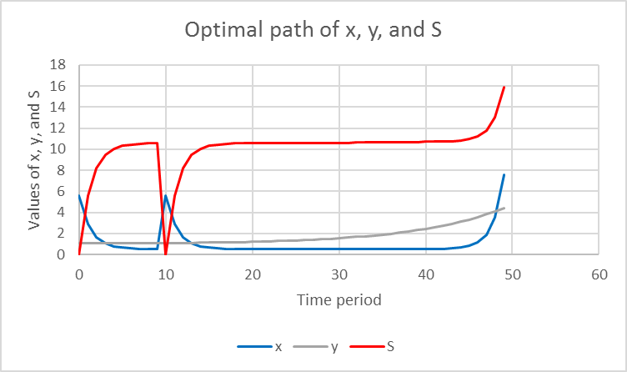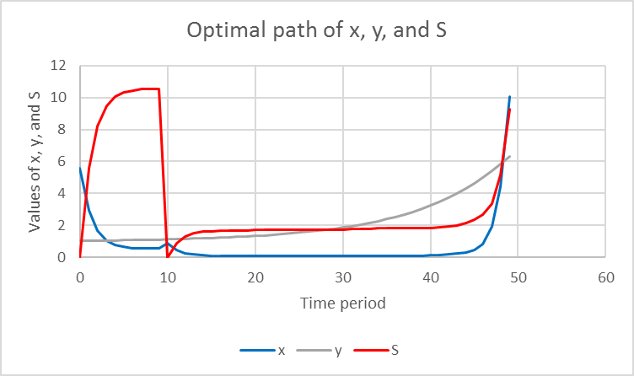
- Re-addiction (S=0 in t=10) (b) Quitting (S=0 in t=10 and c0=4)
Figure 2: Comparative statics analysis.

If you teach rational addiction using a version of Figure 1, with a steady state at C = δS, this graph will make much more sense after using the 50xyS sheet. The student will understand the idea of a path of choices over time and, furthermore, that there is an optimal path where the steady state condition is met.

The 50xyS sheet will also open the door to comparative statics analysis, the heart of the economic way of thinking. Unlike the shifted curves in Figure 1, which are incomprehensible to the typical undergraduate, the visual display in the Excel file enables the student to connect a given shock to a new optimal path. A variety of experiments can be proposed, such as, what does a higher discount rate, ceteris paribus, do to the optimal paths of x, y, and S?

5. Conclusion
This paper offers a novel way to teach Becker and Murphy’s (1988) rational addiction model. It explains how to use a macro-enabled Excel workbook, RationalAddiction.xlsm, to bring the model to life for the typical undergraduate Economics major. It avoids all math for finding the optimal solution, letting Excel’s Solver do the heavy lifting, and walks the student through the logic of the model.

Rational addiction is not a trivial, one-off application. It extends consumer theory beyond the static, two goods subject to a constraint model to a multi-period, optimizing path framework. It has great potential in a variety of places in the Economics curriculum. All four of the Health Economics textbooks in Figure 3 cite Becker and Murphy (1988) and discuss rational addiction. Only the top-selling Folland. et al. (2013) textbook (often used in graduate courses) includes a graph (see Figure 1). Bhattacharya, et al. (2014) integrates rational addiction into an entire chapter titled Time Inconsistency and Health without solving the model.

Title |  |  |  | Show Books Ranked:
Author |  | Edition | ISBN
Economics of Health and Health Care
 | Folland, Sherman | 7TH 13 | 0-13-277369-4
Health Economics
 | Phelps | 5TH 13 | 0-13-294853-2
Health Economics
 | Bhattacharya, Jay | 14 | 1-137-02996-X
Health Economics and Policy
 | Henderson, James W. | 6TH 15 | 1-285-75849-8

Figure 3: Leading Health Economics Textbooks.
Source: www.facultycenter.net accessed January 14, 2019.

In addition to Health Economics or other upper level electives, this Excel implementation of the rational addiction model can be used after consumer theory is covered in an Intermediate Microeconomics course. Courses devoted to quantitative methods might also find this a novel way to introduce Solver and numerical optimization. Finally, many curricula have a senior seminar or capstone experience that could use this application to remind students of the theory of consumer behavior (indifference curves and budget constraints), while extending that basic model in interesting ways.

References

Bhattacharya, J., Hyde, T., and Tu, P. (2014). Health Economics (Palgrave Macmillan).

Becker, G. and Murphy, K. (1988). “A Theory of Rational Addiction,” Journal of Political Economy, 96:4, pp. 675-700. https://www.jstor.org/stable/1830469

Folland, S., Goodman, A., and Stano, M. (2013, 7th ed.). The Economics of Health and Health Care (Routledge).

Henderson, J. (2015, 6th ed.). Health Economics and Policy (Cengage Learning).

Phelps, C. (2016, 5th ed.). Health Economics (Routledge).

