Barreto
Hist Econ

Engels’ Pause: Déjà vu All Over Again?

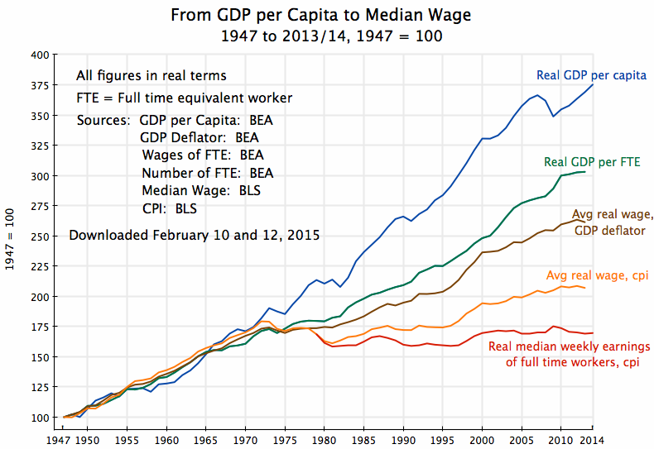
https://aneconomicsense.org/2015/02/13/why-wages-have-stagnated-while-gdp-has-grown-the-proximate-factors/

I’m pretty sure it should be Engels’s Pause, but Allen named it Engels’ Pause so we’re going with that. Look here: https://www.thepunctuationguide.com/apostrophe.html

