The Ghost Map: The Story of London's Most Terrifying Epidemic - and How it Changed Science, Cities and the Modern World by Steven Johnson is an excellent account of how John Snow solved the puzzle of cholera and where it came from. If you are interested in science and like to read a good story, you should read this book. Johnson sets the stage, London in Marx’s day, with an incredible account of the night-soil men. Listen and read along, underlining and circling ideas that catch your attention and jotting notes on the side. You have to be fast and listen carefully.

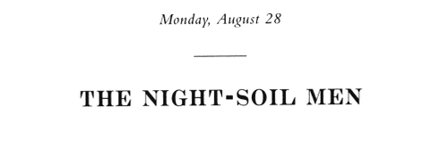
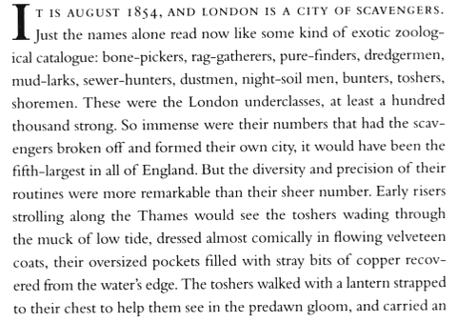
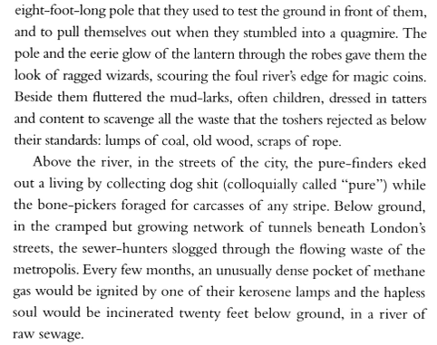
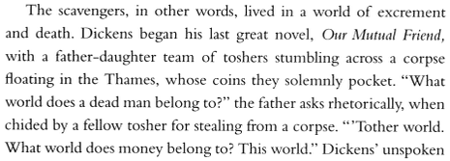. . .
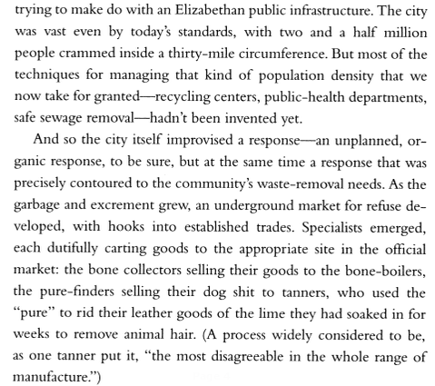
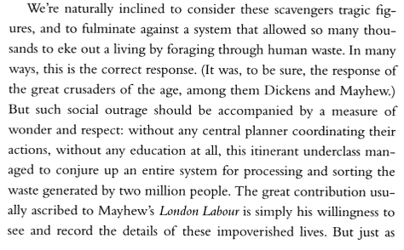
London Labour and the London Poor is a careful, detailed description of London in the 1840s by journalist Henry Mayhew.

and Marx!

  

