**Cuban Demography and Economic Consequences**

Humberto Barreto

Q.G. Noblitt Professor of Economics and Management

DePauw University

Greencastle, IN 46135

July 26-28, 2018 ACSE Meeting, Miami, FL

Please do not quote without permission.

All comments welcome.

Thanks to Frank M. Howland for helping me understand population dynamics and improving the presentation.

Abstract

This paper highlights and explains the effects of various demographic shocks to the Cuban economy, starting from the baby boom of the early 1960s and the collapse in fertility rates thereafter. The primary contribution is a freely available Excel workbook, *PopPyrCuba.xlsm*, that enables projections of population age distributions. For Cuba, the future looks bleak. Japan and other rich countries are finding that demographic forces are quite strong and cause serious economic harm. Without a developed market system, Cuba’s economy offers little protection from the coming storm. There are, of course, many challenges facing post-Castro Cuba, but demography may prove to be the most daunting of all.

JEL Codes: A10, J10

Keywords: fertility, death, population, simulation, Excel, growth, externality

**1.0 Introduction**

Cuba is facing a demographic storm that will stress its economy and society: its large baby boom generation is reaching retirement age and fertility is extremely low. While this is not an original observation (Hollerbach, 1980; Díaz-Briquets, 2015; Díaz-Briquets, 2016), this paper uses single-year age-distribution data to show clearly the seriousness of the situation. Unlike previous work (including that at the Cuban government’s *Oficina Nacional de Estadísticas e Información* (ONE), [www.one.cu](http://www.one.cu)), which focuses on total population change and other aggregates, this paper presents and analyzes the movement of the entire age-distribution over time. Thus, the data display methods adopted in this paper more dramatically show the demographic challenges facing Cuba.

The economic impact of an aging population is usually presented in terms of resources needed for health care and social services. The old age dependency ratio (the fraction of adults over 65 years old) conveys the idea that society must find a way to pay for care of the elderly. While important, this understates the effect of population aging and misses a mechanism through which it influences the economy. A much more serious challenge for an economy than taking care of the aged revolves around the attitudes and expectations of a society dominated by old people. The old are more pessimistic, conservative, and short-run oriented than the young.

While Keynes (1936, Ch 12:VII) highlighted animal spirits, “a spontaneous urge to action rather than inaction,” as a driver of fluctuations in a market economy, economists have little to say about the effect of expectations on long-run growth. Below are rudimentary thoughts on why a society dominated by the old might languish.

The optimism of young people drives their energy and motivation to undertake a whole host of activities, including starting new businesses, trying new products, building new homes, and moving to new cities. The old, unlike the young, see the end of life and this affects their outlook. For many, the past seems better than the future and they stand pat—personally, socially, and economically.

Risk taking falls as people age and this occurs in every aspect of life. We settle into patterns and stick to what works. In terms of the economy, old people are less likely to buy new products and invest aggressively. They are more concerned with maintaining and conserving what they have than in taking chances with their accumulated wealth.

Young people provide a dynamism to the economy that is fundamental to the success of innovation and technological change. General outlook, attitudes toward risk-taking, and time horizon considerations are all highly correlated and change together as we age. We become more negative, careful, and unenthusiastic. These attitudes drag the economy. They have always been there, but they have never been as noticeable and prominent as they are today because of a worldwide revolution in demography.

Countries around the world face aging population distributions that will hamper economic performance. Rich countries, like Japan, are better able to withstand these demographic headwinds. Those that can attract immigrants, like the United States and Germany, can bolster diminishing numbers of younger aged cohorts by welcoming young people from other countries, although this solution is fraught with challenging political and social effects.

Cuba is in a particularly vulnerable position. Not only are the demographic forces exceptionally strong, but the economy is unusually weak. This paper will focus on the former, examining changes in the population age-distribution since the Revolution and forecasting future outcomes. Even if Cuba somehow manages to reform the economy and incorporate market-based incentives, its population age-distribution presents formidable challenges for anyone hoping for an economic take-off. Again, this is not merely an issue of resources devoted to caring for the aged, but requires figuring out how to overcome the stagnation resulting from an economy dominated by old people. Without the energy, optimism, and risk-seeking of the young, the Cuban economy’s long-run future seems bleak.

The next section uses a macro-enabled Excel workbook, *PopPyrCuba.xslm*, to analyze Cuba’s recent demographic past and current situation. Age-specific fertility and death rates are then used to examine future prospects by iteration.

**2.0 The Population Age-distribution in Cuba Today**

Barreto (2018) shows how Excel can be used to directly download male and female, single-year age-cohort data for countries from 1950 to 2050 from the International Data Base (IDB) of the US Census Bureau. Population pyramids are quickly and easily displayed, individual cohorts can be highlighted, and the chart can be animated (showing progression over time). The Cuban data begins in 1981. All the data and charts presented in this paper are in *PopPyrCuba.xlsm*, which is freely available at [academic.depauw.edu/~hbarreto/working](http://academic.depauw.edu/~hbarreto/working).

Cuba’s population pyramid in 2018 (shown in Figure 2.1) is quite striking. There are two distinctive features: (1) a big bulge, with smaller bulges below, and (2) a narrowing bottom. Both are important aspects of Cuba’s demographic story and future evolution.

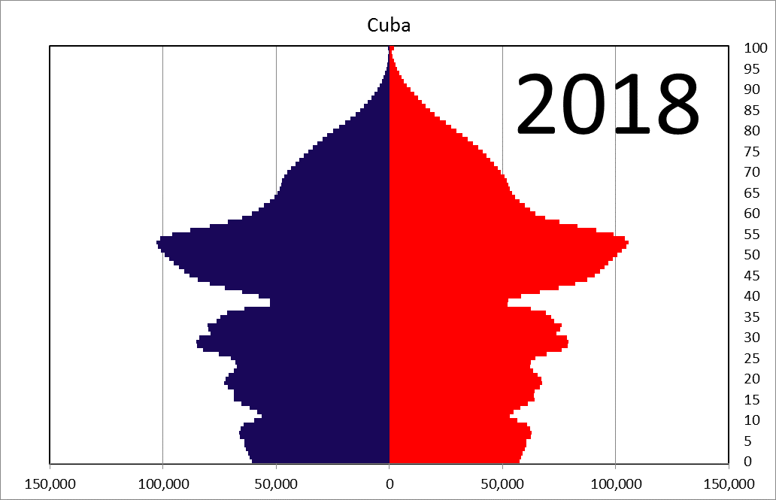

female

male

Figure 2.1: Cuba’s Population Age-distribution Today.

See *Cuba* sheet in *PopPyrCuba.xlsm*.

Data Source: [www.census.gov/data-tools/demo/idb/informationGateway.php](http://www.census.gov/data-tools/demo/idb/informationGateway.php)

The big bulge in Figure 2.1 is Cuba’s baby boom generation, defined here as those born between 1960 and 1975 (43 to 58 years old in 2018), who comprise roughly 3 million of Cuba’s 11 million inhabitants. Díaz-Briquets and Perez (1981) and Hollerbach and Díaz-Briquet (1983) explain that that there was a sudden increase in the number of births after Castro took power, which was followed by a rapid decline in fertility as contraception and abortion became easily available after 1965. Figure 2.1 makes it easy to see that as they retire and age, the baby boom generation will stress the economy and society.

The smaller bulges and waves in Figure 2.1 are not produced by rising and falling fertility rates. Figure 2.2 shows that age-specific fertility rates (ASFRs) have remained relatively stable and quite low from 1990 to 2013. Instead of changing fertility rates, the waves of rising and falling births in Figure 2.1 are driven by the movement of baby boom women through their child-bearing years and then again as their daughters had children.

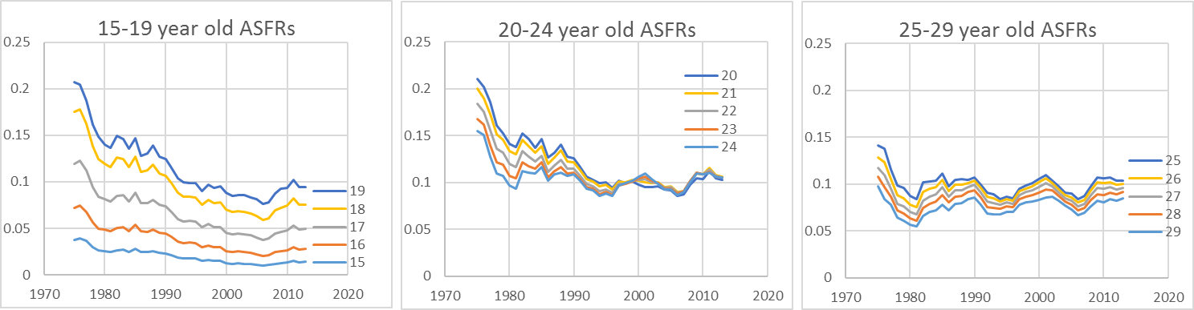

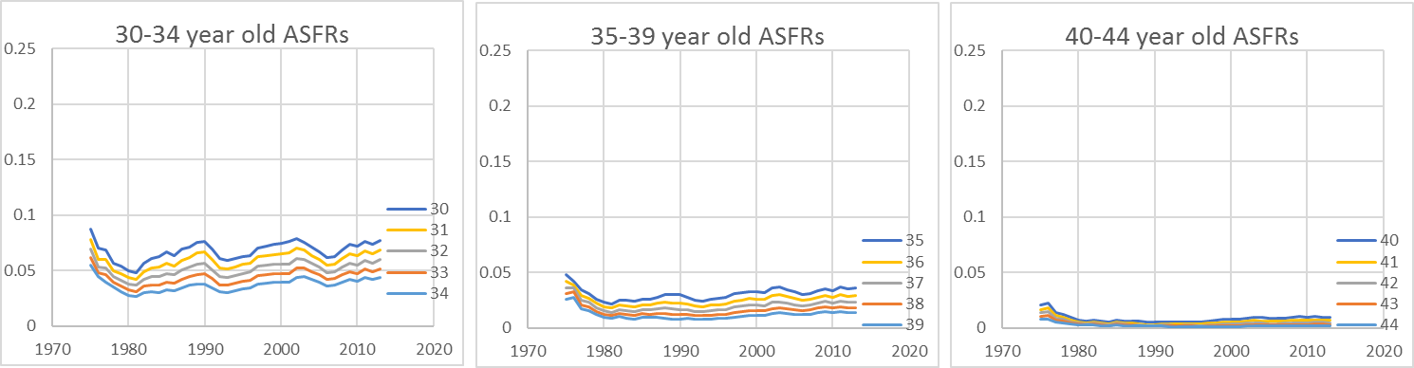

Figure 2.2: Cuban Single-year Age-specific Fertility Rates (ASFRs).

See *ASFR* sheet in *PopPyrCuba.xlsm.*

Data Source: [www.fertilitydata.org/cgi-bin/country.php?code=CUB](http://www.fertilitydata.org/cgi-bin/country.php?code=CUB)

Cuba’s ASFRs are not only quite stable, but also extremely low. Figure 2.3 shows ASFRs in five-year groups for selected years from 1907 to 2013. Cuba’s total fertility rate (TFR), the number of children who would be born per women given existing ASFRs, bottomed out at 1.4 in 2006 and has hovered around 1.7 since then.

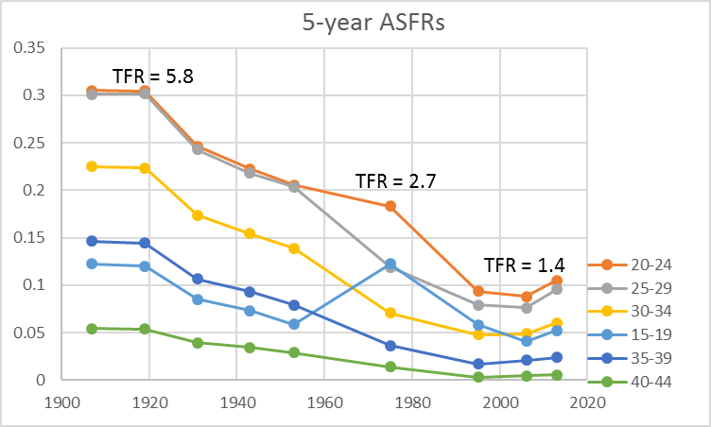

Figure 2.3: Cuban 5-year Age-specific Fertility Rates.

See *ASFR5yr* sheet in *PopPyrCuba.xlsm.*

Data Source: Hollerbach (1980) and [www.fertilitydata.org/cgi-bin/country.php?code=CUB](http://www.fertilitydata.org/cgi-bin/country.php?code=CUB)

Bélanger and Flynn (2009, p. 14) find that Cuba has an “abortion culture,” i.e., “an environment in which abortion is seen as comparable to contraceptive use.” Cubans use both contraception and free, medically safe abortion to prevent having an unplanned child. Andaya (2014, p. 78) writes that “Women continually invoked the phrase, ‘I didn’t have the conditions’ (*no tenia condiciones*)” and there is no stigma or shame, even for pregnant teenagers. In fact, Andaya (2014, p. 81) argues that abortion and extremely low fertility is seen as a marker of modernity: “Cuban women have also come to view fertility regulation as the hallmark of a modern woman and moral mother.” Not surprisingly, this has produced remarkably low fertility rates: “In 2006 Cuba became one of the few low-income countries to have approached, with a total fertility rate (TFR) of 1.39, the ultra-low 1.3 child per woman fertility threshold.” (Díaz-Briquets, 2014, p. 677).

Assuming continued low ASFRs (although fertility is volatile and difficult to predict), the undulating waves seen in Figure 2.1 can be explained simply as a consequence of baby boom mothers proceeding through child-bearing years. The *Fake* sheet in *PopPyrCuba.xlsm* makes clear the dynamics of the process using a hypothetical example. The initial position (as shown by Year 1 in Figure 2.4) has a baby boom of 20,000 males and females in each cohort age 0 to 14 and 5,000 males and females in each cohort aged 15 to 85. Women have equal and constant ASFRs of 0.067 for child-bearing ages 15 to 44 years old (thus, TFR is 2 and the population will be constant in the long run). Everyone has age-specific death rates (ASDRs) of zero until age 85 (when they die). As the baby boom ages and has children (scroll right in the *Fake* sheet), births increase, even though fertility and death rates are held constant (see Year 20 in Figure 2.4). The process will eventually reach a steady-state solution with a constant number of people in each age-cohort, washing out the effects of the baby boomers, but this takes quite a long time. Figure 2.4 shows a few snapshots in time. By Year 70, the baby boomers are elderly and the undulating waves they caused are clearly seen. In Year 100, the baby boomers have passed on and the bulges are receding; Year 200 is close to the steady-state. Scroll right in the *Fake* sheet to see exactly how the age-distribution evolves year by year.

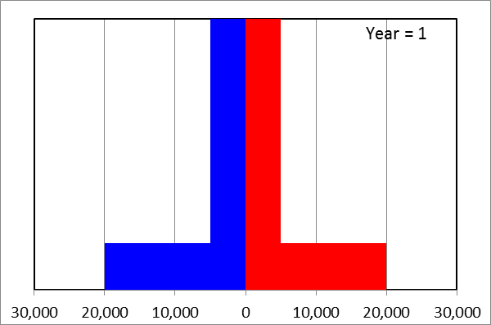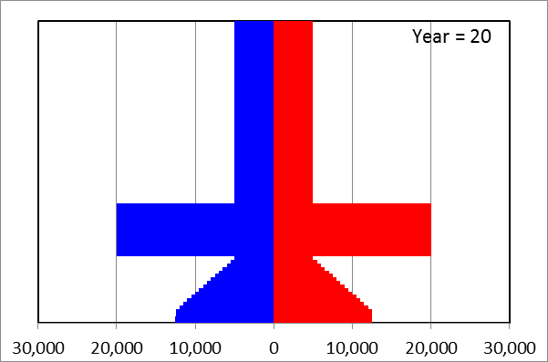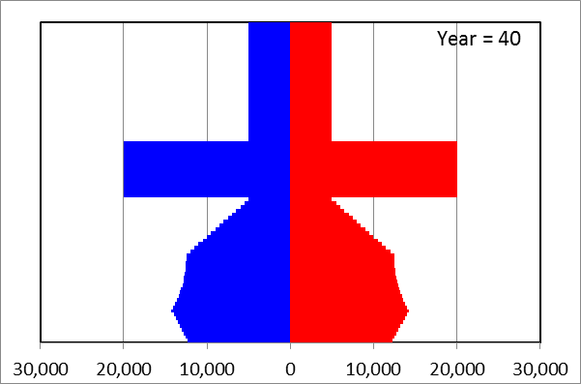

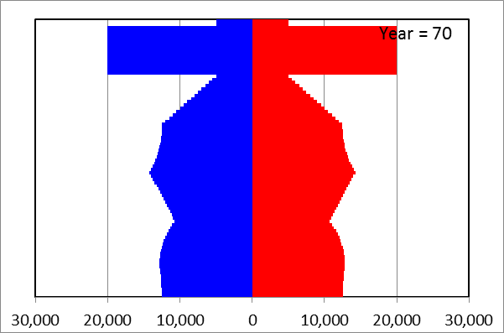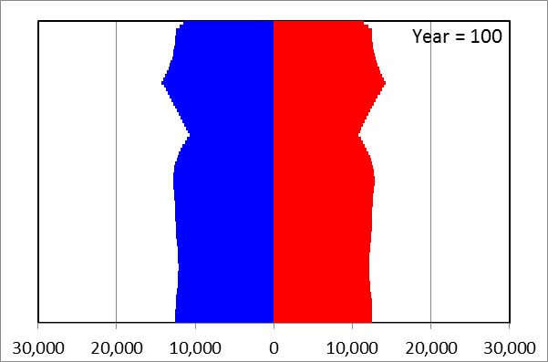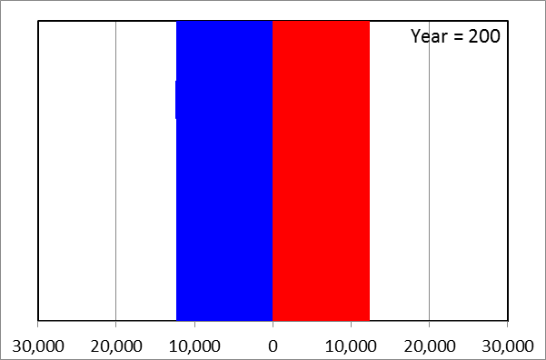

Figure 2.4: Hypothetical Example Illustrating the Effects of a Baby Boom.

See *Fake* sheet in *PopPyrCuba.xlsm*.

Data Source: Simulated data

While economists typically focus on comparative statics exercises, examining the change in initial and final equilibrium positions, simulating the population pyramid enables analysis of the path itself. Year 70 in Figure 2.4 (qualitatively similar to Cuba’s pyramid in a few decades) shows that the baby boom elderly have relatively few working age adults supporting them. This is obviously a precarious position.

Figure 2.1 offers a snapshot of Cuba’s current age-distribution, but by examining previous pyramids, we can better understand how Cuba arrived at today’s demographic position and forecast future scenarios. The sheet *CubaPopPyr* begins with 1981, the earliest data in the IDB for Cuba. Figure 2.5 shows that there were roughly 3.5 million baby boomers aged 6 to 21 years old at that time. Click the  button and then click on a cohort in the chart to highlight the cohort’s mothers. The display emphasizes the relationship between a cohort and the mothers who produced them, reinforcing the dynamic process that is generating the age-distribution.



Figure 2.5: Cuba’s Population Age-distribution in 1981.

See *CubaPopPyr* sheet in *PopPyrCuba.xlsm*.

Data Source: [www.census.gov/data-tools/demo/idb/informationGateway.php](http://www.census.gov/data-tools/demo/idb/informationGateway.php)

Scroll right to 1990, click the  button, and then click the age=0 cohort to produce Figure 2.6. This shows that the mini-baby boom underway in 1990 is being produced by the fact that baby boom mothers are entering their prime child-bearing years. Continue scrolling right to see that the mini-bulges are also produced in this same way, when more females are of child-bearing age. The 2018 pyramid (see Figure 2.1 or scroll to the end of the *CubaPopPyr* sheet) shows that there will be fewer mothers (compared to past cohorts) in the next 20 years which means few births so the base of the pyramid will remain narrow—absent an unexpected shock of some kind.

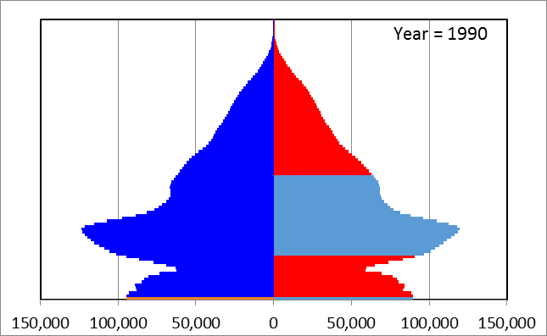

Figure 2.6: Cuba’s Population Age-distribution in 1990 After Clicking the  Button and Age=0 Cohort.

See *CubaPopPyr* sheet in *PopPyrCuba.xlsm*.

Data Source: [www.census.gov/data-tools/demo/idb/informationGateway.php](http://www.census.gov/data-tools/demo/idb/informationGateway.php)

Having considered Cuba’s fertility, we can turn to the other side of life, mortality. The *CubaASDR* sheet uses Cuban age-distribution data to compute age-specific death rates, where death includes migration. In other words, anyone who was on the island one year and is not the next year is counted as dead. This gives a much higher death rate because Cuba has had periods of high migration.

Figure 2.7 shows the set up. There 74,179 age=0 males in 1981 (cell C16) and 73,934 age=1 males in 1982 (cell L17). We can compute the male age-specific death rate (ASDR) for age=0 with the formula “=1 - L17/C16” (cell F17), which yields 0.0033. This is a pseudo-infant mortality rate (IMR). These data do not tell us that 245 male babies died. They simply report how many age=0 males there were in Cuba in 1981 and 1982. Thus, it could be that some babies went to another country in 1981 or (more unlikely) more than 245 babies died and Cuba acquired more one year-olds in 1982 via net immigration. Most improbably, in theory, it could even be that all 74,179 male babies left Cuba and were replaced by a completely different set of 73,945 one-year olds.



Figure 2.7: Using Cuba’s Population Age-distribution to compute death rates.

See *CubaPopPyr* sheet in *PopPyrCuba.xlsm*.

Data Source: [www.census.gov/data-tools/demo/idb/informationGateway.php](http://www.census.gov/data-tools/demo/idb/informationGateway.php)

We can construct ASDRs (including net-migration) from the existing age-distributions for each year. The sheets *ASDRM* and *ASDRF* rearrange the resulting ASDR for males and females, respectively. Figure 2.8 shows a representative set of graphs in these sheets. The remarkable success in lowering IMR is immediately evident in the top-left panel. The severity of the Special Period (after the collapse of the Soviet Union) is also clearly displayed in the spikes in each panel. Scroll right in the *CubaASDR* sheet until 1993 to see the crude death rate (CDR) jump from 0.0078 in 1992 to 0.0097 in 1993 and rise again to 10.8 per thousand the next year. Finally, Figure 2.8 (see also the *ASDRM* and *ASDRF* sheets) reflects the powerful effect of migration. Since we know mortality rates have fallen over time, cohorts with rising “death” rates indicate increases in the fraction of the cohort exiting Cuba. The data show that migration is much higher for 9 year-olds than younger children and for younger adults than for older adults.

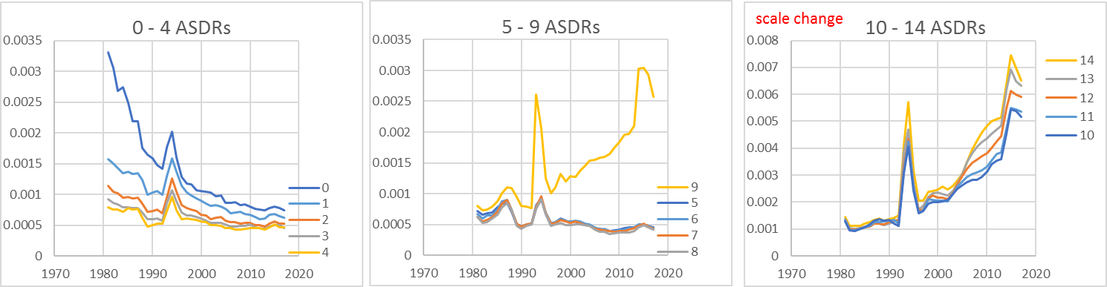

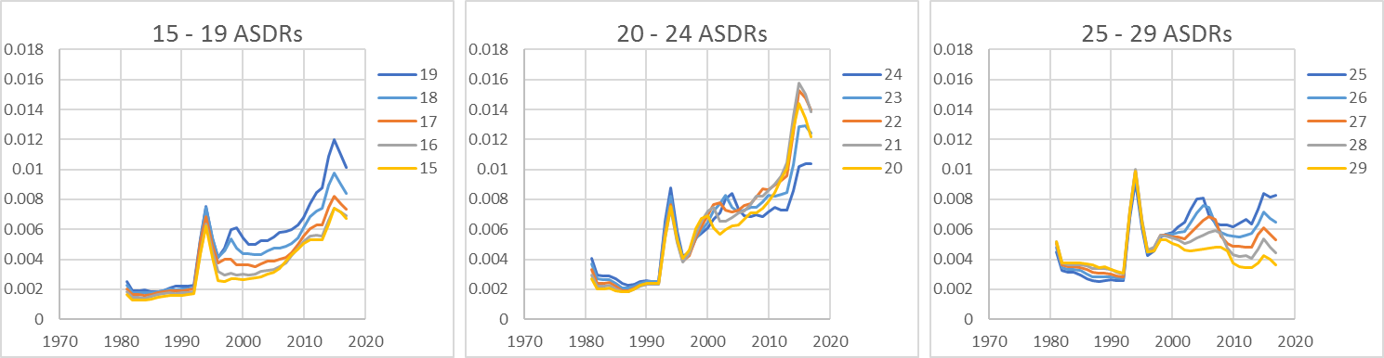

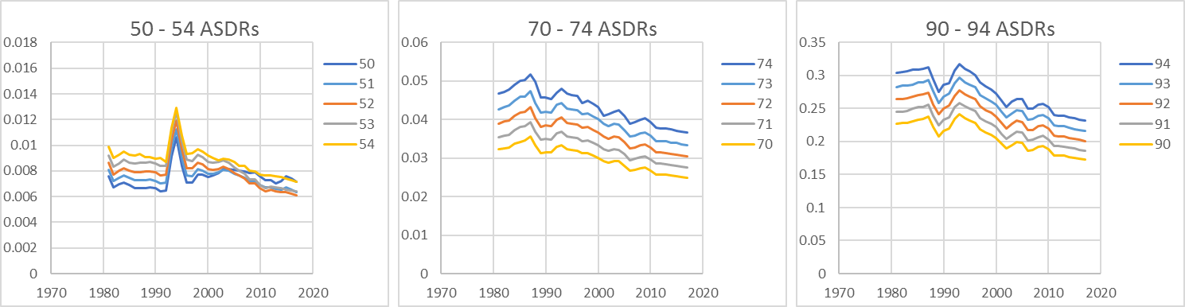

Figure 2.8: Some Male Age-specific Death Rates.

See *ASDRM* sheet in *PopPyrCuba.xlsm*.

Data Source: [www.census.gov/data-tools/demo/idb/informationGateway.php](http://www.census.gov/data-tools/demo/idb/informationGateway.php)

This section has presented the current population age-distribution in Cuba (Figure 2.1) and explored patterns in age-specific fertility and mortality. It is clear and well-known that Cuba’s baby boom generation is aging into retirement and that fertility has been extremely low for several decades. Cuba’s population pyramid reflects both of these facts as a bulge of 43 to 58 year-olds (in 2018) and a narrowing base.

Less obvious, especially given the mini-bulges in the pyramid, is the fact that Cuba’s fertility and death rates have remained relatively stable over the last few decades. The smaller bulges are not caused by fluctuations in fertility rates. Instead, these mini-booms are echoes of the baby boomers as their children age and have children of their own. In fact, applying 2018 ASFRs and ASDRs to the age-distribution in 1990 predicts Cuba’s age-distributions quite well. The next section uses this strategy of applying ASFRs and ASDRs to forecast the age-distribution.

**3.0 Future Population Age-distributions in Cuba**

It is well understood that population projections are unreliable, even at high levels of aggregation. The exercise in this section is merely illustrative and there are no standard errors. The approach is simple: use Cuba’s current age-distribution and iteratively apply today’s ASFRs and ASDRs (holding them constant), producing the next year’s age-distribution from the previous year’s.

The *Future* sheet in *PopPyrCuba.xlsm* does exactly this and Figure 3.1 shows what Cuba’s population pyramid might look like in 2030, when males born in 1960 will be 70 years old and officially eligible for retirement benefits. Notice that the number of people on the island is shrinking (down to 10.4 million) and there are few young people to support the aging population. In 2030, the first cohort from the baby boom total of 2.6 million people—a quarter of the population—will begin the process of exiting the labor force.



Figure 3.1: Cuba’s Projected Age-distribution in 2030.

See *Future* sheet in *PopPyrCuba.xlsm*.

Data Source: 2018 ASFRs and ASDRs applied to 2018 age-distribution.

The old age dependency ratio is the number of people 65 and older per 100 people aged 15 to 64 years old. This measure will increase from 22 in 2018 to a relatively high 34 in 2030 (cells I20 and DY20, respectively). As the baby boomers age, the dependency ratio will rapidly rise, reaching a remarkably high 48 in 2040 (as shown in Figure 3.2).

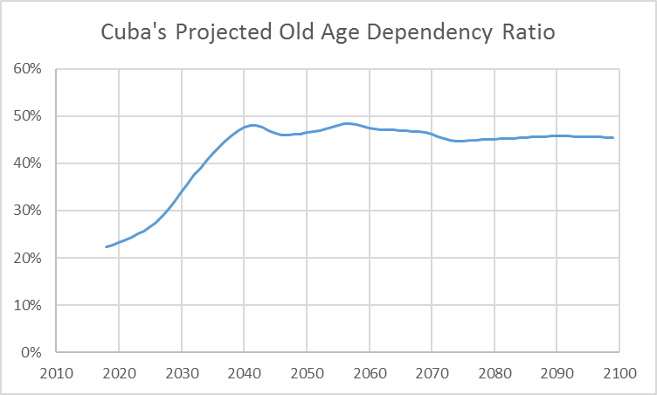

Figure 3.2: Cuba’s Projected Old Age Dependency Ratio.

See *DepRatio* sheet in *PopPyrCuba.xlsm*.

Data Source: 2018 ASFRs and ASDRs applied to 2018 age-distribution.

The projection assumes constant age-specific fertility, death, and migration (which is baked into the ASDRs) and this, of course, is far from certain. Of these, migration seems the most volatile. It is unclear how relations with the United States will change, but anything that allows Cubans to leave will only worsen the demographic picture. Fertility is also highly variable, but it is difficult to envision a rollback of reproductive rights. Even if there is a movement away from abortion, contraception seems to be here to stay and ASFRs will probably remain quite low. Mortality is the most stable of the three and it is likely to continue its gradual decline. This is not included in the projections in Figures 3.1 and 3.2, which hold ASFR and ASDR constant.

Predictions further in the future are even more precarious, but we can continue to evolve the process to see where we are headed at this time, given current fertility, death, and migration rates. Figure 3.3 shows the population pyramid in 2060, when the oldest baby boomers (born in 1960) are 100 years old. Notice that the population has shrunk quite a bit (from 11 million in 2018 to 7.5 million) and there are many more old women than old men.



Figure 3.3: Cuba’s Projected Age-distribution in 2060.

See *Future* sheet in *PopPyrCuba.xlsm*.

Data Source: 2018 ASFRs and ASDRs applied to 2018 age-distribution.

Continue scrolling right in the *Future* sheet to see a forecast for the year 2100, which is a surprisingly small population of only 4.5 million. Of course, this is just a guide to where Cuban society is headed and should not be taken as any kind of firm prediction. It does indicate, however, that, at this point in time, the number of people in Cuba is spiraling downwards. That can change, especially with a government that can quickly set new policies or given the possibility of massive and sudden technological shocks (in procreation and health care).

The US Census Bureau provides estimates of the Cuban population age-distribution and these data are in the *Cuba* sheet. Figure 3.4 (also available in the *FutureComp* sheet) compares my forecast to the IDB data for 2050. My estimate of future population is much smaller. My ASDRs include migration (held constant at 2018 levels) and IDB does not. It is unclear how migration will affect Cuba in the future, except we can be sure it will play a critical role.



Figure 3.4: Barreto Forecast Compared to IDB.

See *FutureComp* sheet in *PopPyrCuba.xlsm*.

Data Source: 2018 ASFRs and ASDRs applied to 2018 age-distribution and

[www.census.gov/data-tools/demo/idb/informationGateway.php](http://www.census.gov/data-tools/demo/idb/informationGateway.php).

**4.0 Conclusion**

Although the demographic challenge facing Cuba and its low fertility have been known for years, the primary contribution of this paper lies in the presentation of the data through the macro-enabled Excel workbook, *PopPyrCuba.xlsm*, freely available at [academic.depauw.edu/~hbarreto/working](http://academic.depauw.edu/~hbarreto/working). Cuba’s single-year population pyramid (Figure 2.1) offers an eye-catching display and, by utilizing simulation to evolve the process, we gain insight into the future prospects facing Cuba. In addition, this paper argues that the implications of an aging population for the economy need to be studied in much more detail.

Discussing teaching and learning at the university level, Marshall (1920, p. 822) said, “The springs of imagination belong to early youth: it is the greatest of all faculties; and in its full development it makes the great soldier, the great artist, the student who extends the boundaries of science, and the great business man.” Indeed, imagination, creativity, and discovery drive technological change and modern economic growth relies on waves of imaginative young people creating wonderful new ways to heal, entertain, and connect us.

It is no coincidence that, during the explosion of development enjoyed by the rich countries of the world in the last two centuries, population and educational attainment have been rising. There has been a constant stream of more educated young people replacing and revitalizing society, sending income per person ever higher. The innovation and technological progress that drives the engine of economic growth is itself dependent on imagination—the springs of which belong to the young. Creativity is less likely to be found in the old because their experiences discourage them from trying all possible solutions to a problem.

Furthermore, parents are willing to undertake heroic and expensive efforts on behalf of their children. Parents deny themselves present consumption to provide a better future for their children. Economies without this kind of forward-looking orientation will invest less and grow more slowly.

Over the next decades, we will get data on how economies function in the presence of smaller cohorts of young people. Japan is a leader in this unfortunate race (see the *Japan* sheet in *PopPyrCuba.xlsm*) and the early returns are not promising. Their economy has not fared well after decades of superb post-WWII growth and no standard policy has managed to shake it out of its doldrums. Luckily, Japan is a rich, developed country. Cuba is not and it is facing the same demographic headwinds as Japan.

There do not seem to be any practical policy levers to pull. Mortality is essentially exogenous. We can safely expect small, continued improvement in health and longevity in countries all around the world. Fertility is the key variable here, but we do not understand it well (long-run prediction has been dismal), but there is no reason to expect a Cuban fertility boom. Many countries have tax credits, baby bonuses, parental leaves, and other supports, but these are small relative to the total cost of raising a child and even if they were effective, the Cuban government does not have the resources for ambitious programs to increase fertility. Immigration (the solution, however unwittingly, adopted by the United States) seems highly unlikely to help Cuba withstand the coming demographic storm. Any easing of barriers to movement on the part of Cuba or other countries (especially the United States), would seem to exacerbate Cuba’s demographic challenge since more young adults are likely to leave Cuba than enter.

Viewing the number of children as a choice variable that responds to incentives leads to the realization that family planning is an outstanding example of an externality—a cost or benefit not taken into account by the decision-maker. The usual examples in economics involve pollution and education—the former a negative and the latter a positive externality. Standard economic theory says that because negative externalities result in too much of a good or service, we should tax them; but we subsidize positive externalities because they lead too few resources allocated in a given area. The optimal tax or subsidy would close the gap between private and social costs and benefits. This framework was developed by Pigou (1920). He supported taxing sellers of alcoholic drinks, zoning laws, and other government interventions as necessary measures to correct what would come to be known as market failures—misallocation of resources in the presence of a market imperfection such as monopoly or externalities.[1]

Since parents do not capture the societal benefits of children, which are a function of the population’s age-distribution, they do not include these benefits in deciding how many children to have. Countries with inverted population pyramids are in a situation in which too few children are being produced and there is no effective way to signal the need for an increased quantity to individual decision-makers. The externality, in which the full benefit (to society) of having a child cannot be captured by its parents, prevents the system from self-correcting.

Absent a sea change in attitudes toward children, a reduction in the economic penalties women must pay to have children, or a technological revolution in how we produce human beings, we should expect that relatively low fertility rates will persist in Cuba and many other countries. The adjustment as population pyramids invert worldwide will not be easy. Cuba, with a weak economy and an especially large elderly cohort, seems to be in a dire position as it becomes the island of the old.

**References**

Andaya, Elise, 2014, *Conceiving Cuba: Reproduction, Women, and the State in the Post-Soviet Era* (Rutgers University Press).

Barreto, Humberto, 2018, “Let's put demography back into economics: Population pyramids in Excel,” *The Journal of Economics Education*, Vol. 49, No. 1, pp. 91 – 101. [www.tandfonline.com/eprint/dfRCkxwwrK8jFAMXxde4/full](http://www.tandfonline.com/eprint/dfRCkxwwrK8jFAMXxde4/full)

Bélanger, Danièle and Flynn, Andrea, 2009, “The Persistence of Induced Abortion in Cuba: Exploring the Notion of an "AbortionCulture",” *Studies in Family Planning*, Vol. 40, No. 1, pp. 13-26. [www.jstor.org/stable/25593932](http://www.jstor.org/stable/25593932)

Díaz-Briquets, Sergio and Perez, Lisandro, 1981, “Cuba: The Demography of Revolution,” *Population Bulletin*, Vol. 36, No. 1, pp. 1 – 41.

Díaz-Briquets, Sergio, 2014, “Accounting for recent fertility swings in Cuba,” *Population and Development Review*, Vol. 40, No. 4, pp. 677-693.

Díaz-Briquets, Sergio, 2015, “Major Problems, Few Solutions: Cuba’s Demographic Outlook,” *Cuban Studies*, Vol. 43, pp. 3 – 18.

Díaz-Briquets, Sergio, 2016, “Population Ageing in Cuba: Policy Options from a Global Perspective,” *ASCE Proceedings 2016*, <https://www.ascecuba.org/asce_proceedings/population-ageing-in-cuba-policy-options-from-a-global-perspective/>

Hollerbach, Paula E., 1980, “Recent Trends in Fertility, Abortion and Contraception in Cuba,” *International Family Planning Perspectives*, Vol. 6, No. 3, pp. 97-106. [www.jstor.org/stable/2947598](http://www.jstor.org/stable/2947598)

Hollerbach, Paula E. and Díaz-Briquets, Sergio, 1983, *Fertility Determinants in Cuba*. National Academy Press: Washington, DC. Committee on Population and Demography, Report No. 26. <https://books.google.com/books?id=VT4rAAAAYAAJ>

Keynes, J. M. (1936). *The General Theory of Employment, Interest and Money*, [www.marxists.org/reference/subject/economics/keynes/general-theory](http://www.marxists.org/reference/subject/economics/keynes/general-theory/).

Knight, Frank H., 1924, “Some Fallacies in the Interpretation of Social Cost,” *The Quarterly Journal of Economics*, Vol. 38, No. 4, pp. 582-606. [www.jstor.org/stable/1884592](http://www.jstor.org/stable/1884592)

Marshall, Alfred, 1920, *Industry and Trade* (Macmillan and Co., Ltd.). <https://books.google.com/books?id=wATtAAAAMAAJ>

Pigou, Arthur C., originally published 1920, 1932 4th ed., *The Economics of Welfare,* (Macmillan). [oll.libertyfund.org/titles/1410](http://oll.libertyfund.org/titles/1410)

United States Census Bureau, International Data Base. [www.census.gov/data-tools/demo/idb/informationGateway.php](http://www.census.gov/data-tools/demo/idb/informationGateway.php)

1. In the first edition of *The Economics of Welfare*, Pigou included an example based on traffic congestion (drivers fail to include the cost of increased traffic), but removed it from future editions after Knight (1924) pointed out that the problem could be solved by private ownership of the road. This led, decades later, to the Coase Theorem. This view holds that resources are misallocated in the presence of externalities because property rights are not clearly delineated. Thus, externalities do not produce market failures, they are a consequence of a missing markets.